- Data Import
- Download northwind-db.sql from classroom
- Open XAMPP and Click Explorer
- Copy downloaded database to mysql folder.
- Open Shell from XAMPP Admin Panel.
- Create database <yourname>northwind and exit
Query: cr
eate databas 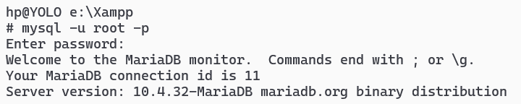
- Import database in <yourname>northwind using following command at SHELL
Query: mysql -u root -p rajeshnorthwind < c:\xampp\mysql\northwind-db.sql
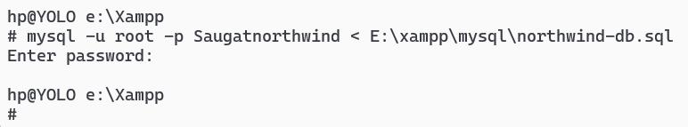
- Connect to database
- Use <yourname>northwind database using

- Query:

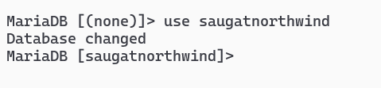

(ii) Show tables
Query:

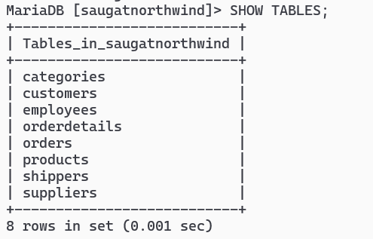
(iv) Check attributes and constraints in each tables
Querey:

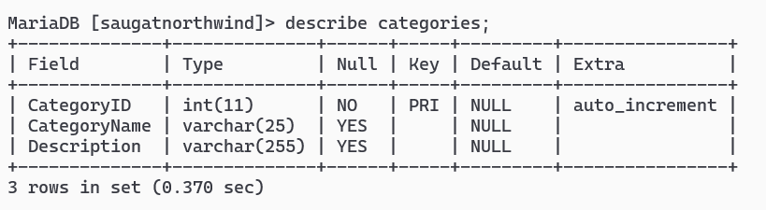
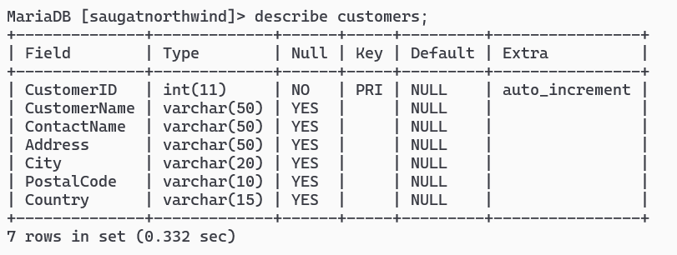

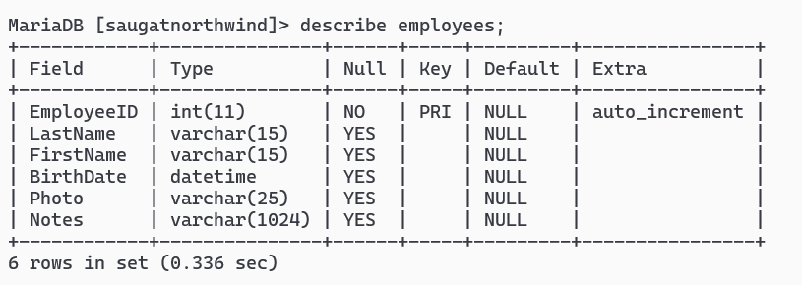
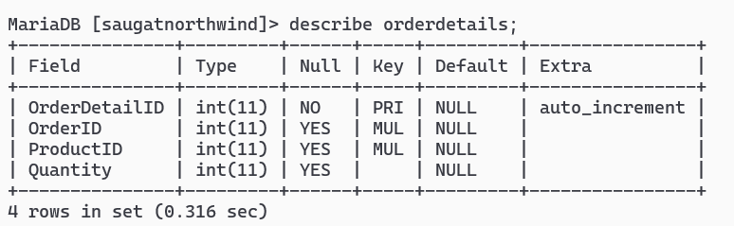
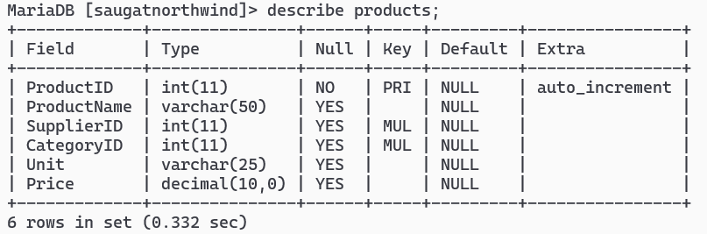
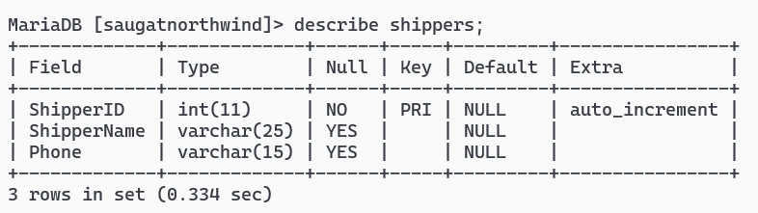
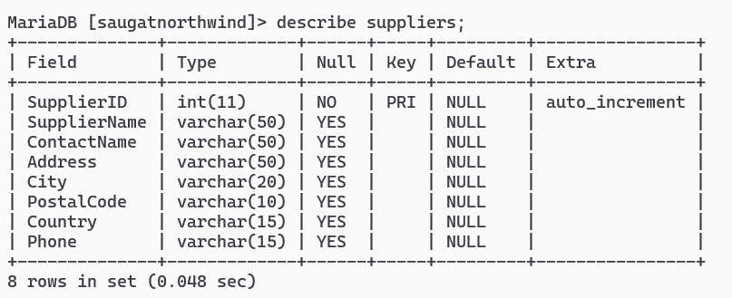

2. Draw Entity Relationship Diagram

